Credit Scores
We all need loans at some point right? Buying a car, buying a house, or student loans.
Let’s pretend you’re a bank, or a rich person that wants to lend out money.

You have 3 “beings” to lend money to. . .

Spike Yabi Woody

Spike | Yabi | Woody
Loves borrowing money | Yabi’s…. Well Yabi | Woody’s a frickin star
Doesn’t pay back on time | Mostly pays on time | Always pays on time
If paid, not the full amount | Makes the minimum mostly | Pays in full
Bad borrowing history | Does full once in awhile | Doesn’t over spend

8%? | 6%? | 2%?

20,000x0.08 = $1,600 | 20,000x0.06 = $1200 | 20,000x0.02 = $400

Fico guy comes along….
Score range = 300~850
Spike | Yabi | Woody
350 | 680 | 800

What if Spike was a mother of 3 children with 2 part time jobs… Do you think they care?

When buying a house, how much of a $$ difference do you think a credit score would make?

So how do I get a super credit score?
There’s a bunch behind it, but I’ll list the basics here.
1. The history of your credit. For example, how long have you had a credit card? Woody has had a credit card for 20 years so he’s pretty awesome according to the banks. Spike’s had a credit card for like 1 year.
2. You don’t spend above 30% of your total credit. Woody can borrow up to $10,000 but he only uses up to $3,000 because he likes to prove that he doesn’t go on a spending frenzy. Spike can borrow up to 10,000, and tries to spend $8000.
3. How many credit cards and loans do you have? Woody has 2 credit cards, while Spike has 8 credit cards, 2 student loans, 1 auto loan, and 1 payday loan.
4. How frequently do you apply for stuff? Woody doesn’t really apply for many credit cards or multiple loans. Spike is taking grabs at every new credit card offer that comes along.
5. You always pay it off on time, and in full. Woody always pays off his credit cards every month on the first available payment date. He’s a frickin star. Spike misses payments a lot.
6. How bad have you been messed up in the past? Woody has never filed for bankruptcy, and he has never foreclosed on a home or failed on a car loan. Spike started like 2 weird businesses and failed both of them. He also failed to make car payments, and home payments too.

Discussion: How important are credit scores?

To remember the key points, “OH, 30” can be helpful.

O = On time
H = History
30 = less than 30%

Credit Card
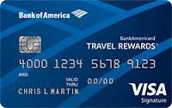

I used to be anti credit card… Why might have that been?

Why credit cards part1:

Credit cards let you build your credit score

Why credit cards part 2:
Credit cards give you points, and we all like points. For example, some credit card companies do things like “1% cash back”. That means that if you spend $1000, you get $10 back.
Why credit cards part 3: Credit card companies compete with each other, so they do special bonus offers to get you to join. Recently I was offered a 50,000 bonus mile ($500) offer, if I signed up with a certain brand. The catch is that I have to spend $3,000 within the first 3 months of opening the card.
Why credit cards part 4: Credit cards have added benefits like “rental car insurance” so you don’t have to buy insurance every time you rent a car. If you have a credit card with airlines, they might give you benefits like “priority boarding”, “1st checked bag free” and “special lounge access” all that fancy stuff.

What’s the catch? The catch is that credit cards can destroy your finances if you screw up. Let’s do an example….So let’s say Spike puts $10,000 on the credit card, and isn’t able to make the full payment at the end of the month. Spike decides to pay the minimum payment, which is $25. This let’s Spike worry about this big bill next month. However, next month Spike will have to pay the high interest rate the credit card company charges which is 30% APY. That means it’s 2.5% per month. What’s 2.5% of 10,000? It’s $250. So Spike ends up having to pay $250 just in interest. Don’t be like Spike, that’s a scary path to go down. Oh and another thing, if Spike isn’t able to make the next payment it will destroy his credit score.

How do you think Spike would use a credit card, and how would Woody use a credit card?

Review

So we covered credit cards and credit scores.

What are the 3 ways to increase your credit score?

OH, 30

O= on time

H= history
30= use less than

What’s with the Fico guy?

Using a credit card is like playing a dangerous “life” game.

What are the pros?

What are the cons?

How is Spike different from Woody?

Buying a car

I might get a…
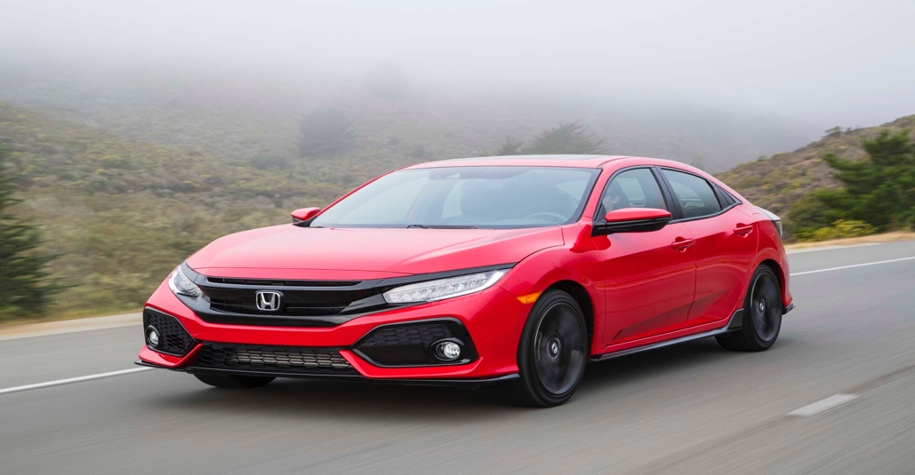

$23,000 Car | 3% | 6 years to pay it off

So let’s go here to see what it looks like…
http://www.bankrate.com/calculators/mortgages/loan-calculator.aspx

Pymnt per m=$349.45 | $2160.73 is their profit | That’s 9.4% of the...
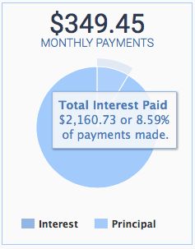

I don’t want them to profit in interest… Okay, so you don’t want them to make that extra $2100 or so, then what could you do? You could save $23,000 in your savings account, walk into the store, and drive away with a car…..

Other option No.1 = have a super credit score: Let’s say you’re a financial ninja, and you have a killer credit score of 810. Let’s do the example above with a 2% interest rate….
Your monthly payments = $339.26.
Your total interest you give the lender = $1426.73 which is 6.2% of the original Comparison of you with a super credit score versus not a super credit score: $2160.73 - $1426.73 which is $734. Boom!

Other option No.2 = Super down payment:

You’ve saved up $8000
So now you only have to get a $15,000 loan instead of the $23,000
Your monthly payment = $227.91.

Total interest you give to the lender = $1409.73 which is 6.12%
Comparison of you with a super down payment versus not a super down payment: $2160.73 - $1409.73 which is $751. Boom!

Other option No.3 = pay it off super quickly:
pay it off in 2 years.

Payment = $988.57
Total interest you give to the lender = $725.63.
Let’s do the comparison of you with a super quick payoff versus not a super quick payoff:
$2160.73 - $725.63 which is $1435.1. Boom!

Savings Chart
Super Credit Score | Super Down Payment | Super fast off
$734 | $751 | $988

Way of the Financial Ninja
$1435

Just remember
C
D
T

Discussion:
What is realistic for you? Can you do this when you get your car?

Can you buy a second hand car?

Activity: Let’s do simulations and play with numbers.
Google: “bank rate loan calculator” → click on the one that’s not an add

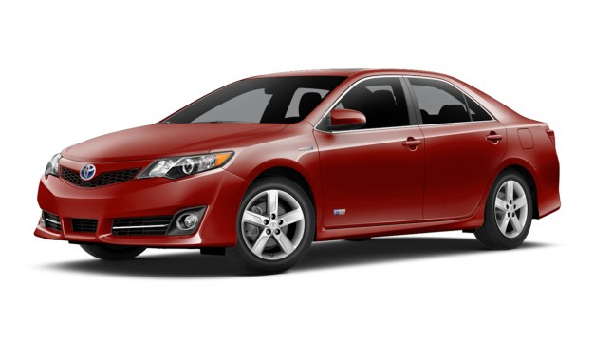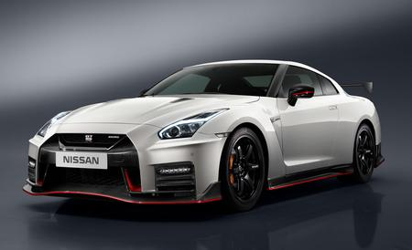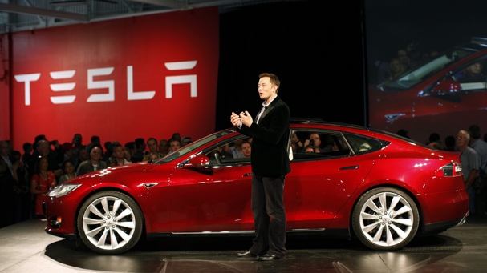

Toyota Camry = $23,000

Nissan GTR = $110.000

Tesla = $75,000

Ford F250 = $33,000

Buying a house

“I might get a…” $300,000 house. You’re thinking that it’s in a good location, good school for the kids, and plenty of property. Let’s say you plan to pay it off in 30 years, and you get a 5% interest rate. So again, $300,000 house, 5%, 30years. Use this site to play around with numbers and pictures: http://www.bankrate.com/calculators/mortgages/loan-calculator.aspx?l
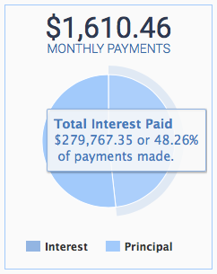

You find out your payment will be $1610.46 a month. You also find out that by the time you’re done paying for that house, you give them (bank) an extra $279,767.35 which is 93.26% of the original amount. Let’s go over that one more time. If you buy a $300,000 house, and pay it off in 30 years with a 5% rate. By the time you’re done paying for it, you give the bank an extra $279,767.35. Like…What the *$* !@#!?.................Welcome to house buying.

Other option No.1 = have a super credit score: Let’s say you’re a financial ninja, and you have a killer credit score of 810.
Example:
Rate = 4% interest rate
Your monthly payments = $1432.25.
Total interest you give the lender will be $215,608.52 which is 71.2% of the original amount. Comparison: $279,767.35 - $215,608.52 which is $64,158.83. Boom!

Other option No.2 = super down payment:

You’ve saved up $100,000
Now you only have to get a $200,000 loan instead of the $300,000
Your monthly payment = $1073.64.
Total interest you give to the lender = $186,511.57 which is 62.2%

Comparison: $279,767.35 - $186,511.57 which is $93,255.78. Boom!

Other option No.3 = pay it off super quickly:

Pay it off in 15 years

Monthly payments = $2,372.38
Total you give to the lender = $127,028.56.

Comparison: $279,767.35 - $127,028.56 which is $152,738.79. Boom!

The way of the ninja: This is what a financial ninja would do. Super credit score, super down payment, and super quick payoff.
The ninja would do a $100,000 down payment so it would look something like $200,000 with 4% in 15 years. The ninjas monthly payment would be $1479.38.
Total interest you pay to the lender = $66,287.38 which is 22.1% of the original amount. Comparison: $279,767.35 - $66,287.38 which is $213,479.97. Jaw drop.

Savings Chart
Super Credit Score | Super Down Payment | Super fast off
$64,158.00 | $93,255.00 | $152,738.00

It’s CDT!

C =

D =
T =

Way of the Financial Ninja
$213,479.00
Let’s play around on the bankrate website.

Student Loans

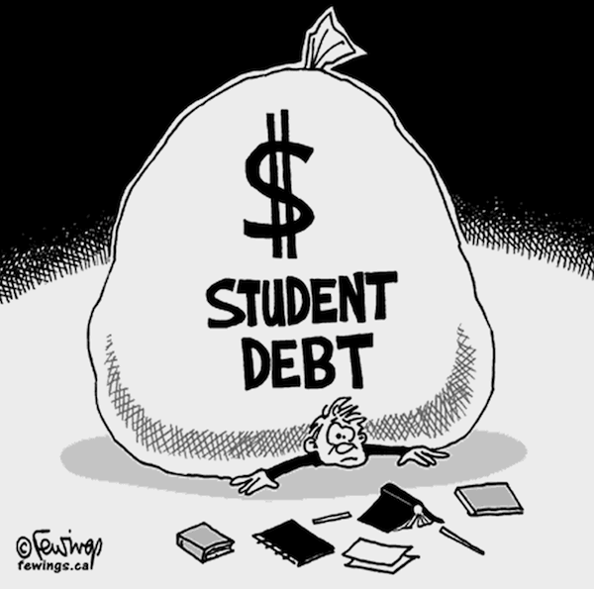

Review… What did we talk about last time?

How did car loans and house loans work?

How do college loans work?

How do you figure out how much you pay the lender? ….

So let’s face good old reality…. Let’s come up with an estimate of how much loans you will accumulate.

Discussion

What are your thoughts?

Can you apply CDT?

c=
d=
t=

Is it worth it to get a loan for college?
http://www.pewsocialtrends.org/2014/02/11/the-rising-cost-of-not-going-to-college/

How important is your major?
http://www.payscale.com/college-salary-report/majors-that-pay-you-back/bachelors?page=3
What tactics could you use if college is too expensive?

Stocks

It’s just a line that goes up and down

It’s a piece of a company

Let’s do some basic math review.

What’s 10% of $1,000?

What’s 5% of $1,000?

What’s 10% of $10
Let’s do a Facebook stock example… how much money would you make?
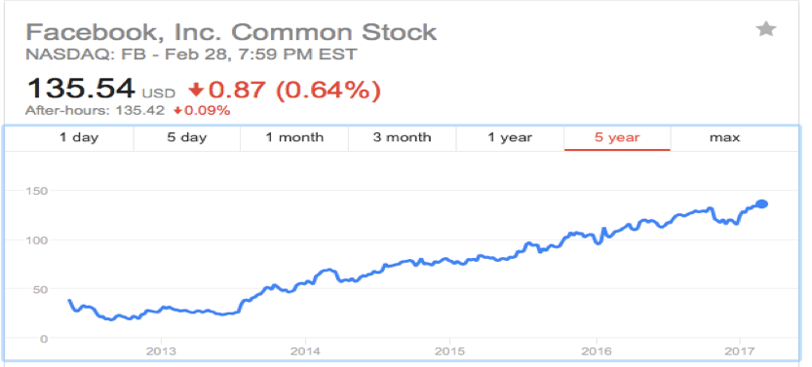

How about Snap chat?

How about Chipotle

Story about planet fitness.

Any questions?

Resources you can use = wallstreet survivor for practice

Resources you can use = robinhood for real trades

How you could save $1million (Individual Retirement Account) IRA

This is the most important topic!

So you know how we talked about…
stocks
the S&P 500 does about 7% per year.

Let’s get into the time machine…
So let’s say you open a retirement account in 1990 and started with $1,000. After one year, it goes up 10%. Now you have $1,100 right? Let’s say the year after that it goes up another 10%, then it becomes $1,210 ($1100x10% = $110… So add $110 to $1,100). You might think okay big deal… Well it’s not.

Going forward in the time machine…

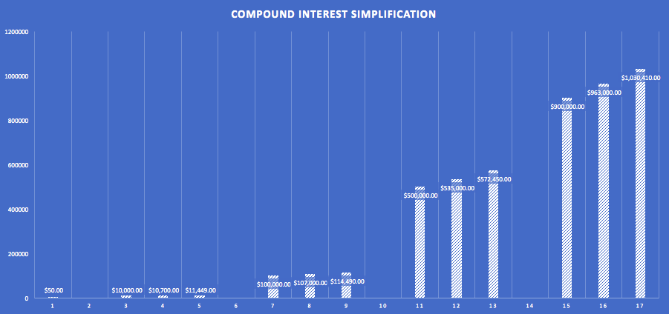

So how do I open one….

ID
social security
proof of income, and $50 (hopefully the minimum).
You also need to go to a place that lets you open retirement accounts (there’s plenty out there so pick what you think is right).

So what types of investments do I put it in?
There’s basically 3 levels. Aggressive, Moderate, and Conservative.
Aggressive = Stocks. High risk, high potential.
Moderate = Mix of stocks and bonds.(Bonds are like super safe investments with small returns)
Conservative = Bonds mostly. (super safe)
What people tend to say is “when you’re young, go aggressive” “When you’re old, go conservative”

What do you do Kael?
I’m young (ish) so I pick investments more on the aggressive side. For example, I own a thing called a ETF that copies what the S&P 500 does. The ticker is called SPY, go ahead and look it up to do your own research.

Do your own research!

- Warning you of the dangers…
- Greedy banks…
- Your retirement account can suddenly crash…

- Don’t touch it…

